**PROGRAM 1**

**Consider the Insurance database given below. The primary keys are underlined and the data types are specified.**

**PERSON (driver-id #: String, name: String, address: String)**

**CAR (regno: String, model: String, year: int)**

**ACCIDENT (report-number: int, date: date, location: String)**

**OWNS (driver-id #: String, Regno: String)**

**PARTICIPATED (driver-id: String, regno: String, report-number: int, damage-amount: int)**

1. **Create the above tables by properly specifying the primary keys and the foreign keys.**

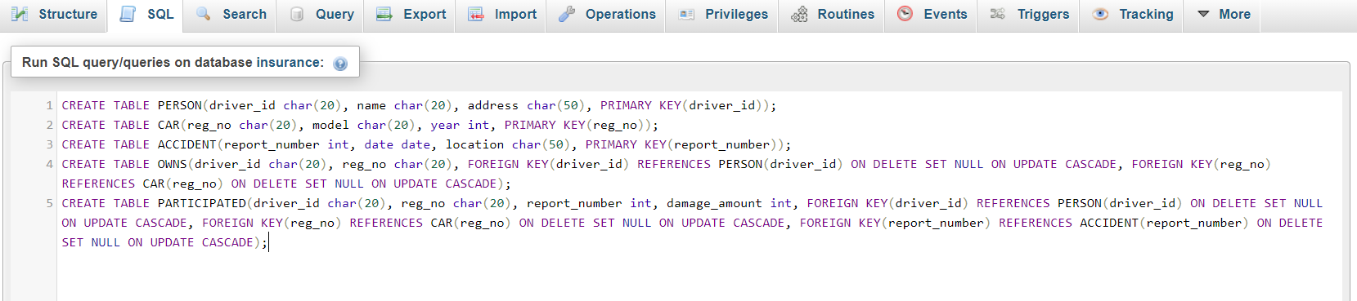

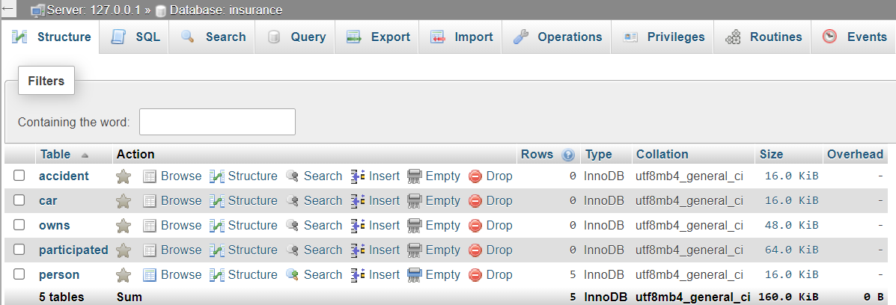

1. **Enter at least 5 tuples for each relation.**

**‘PERSON’ table:**

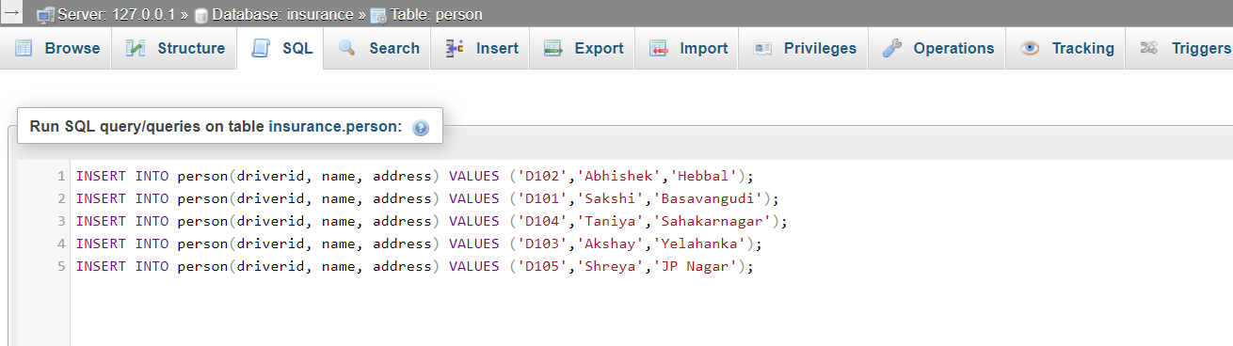

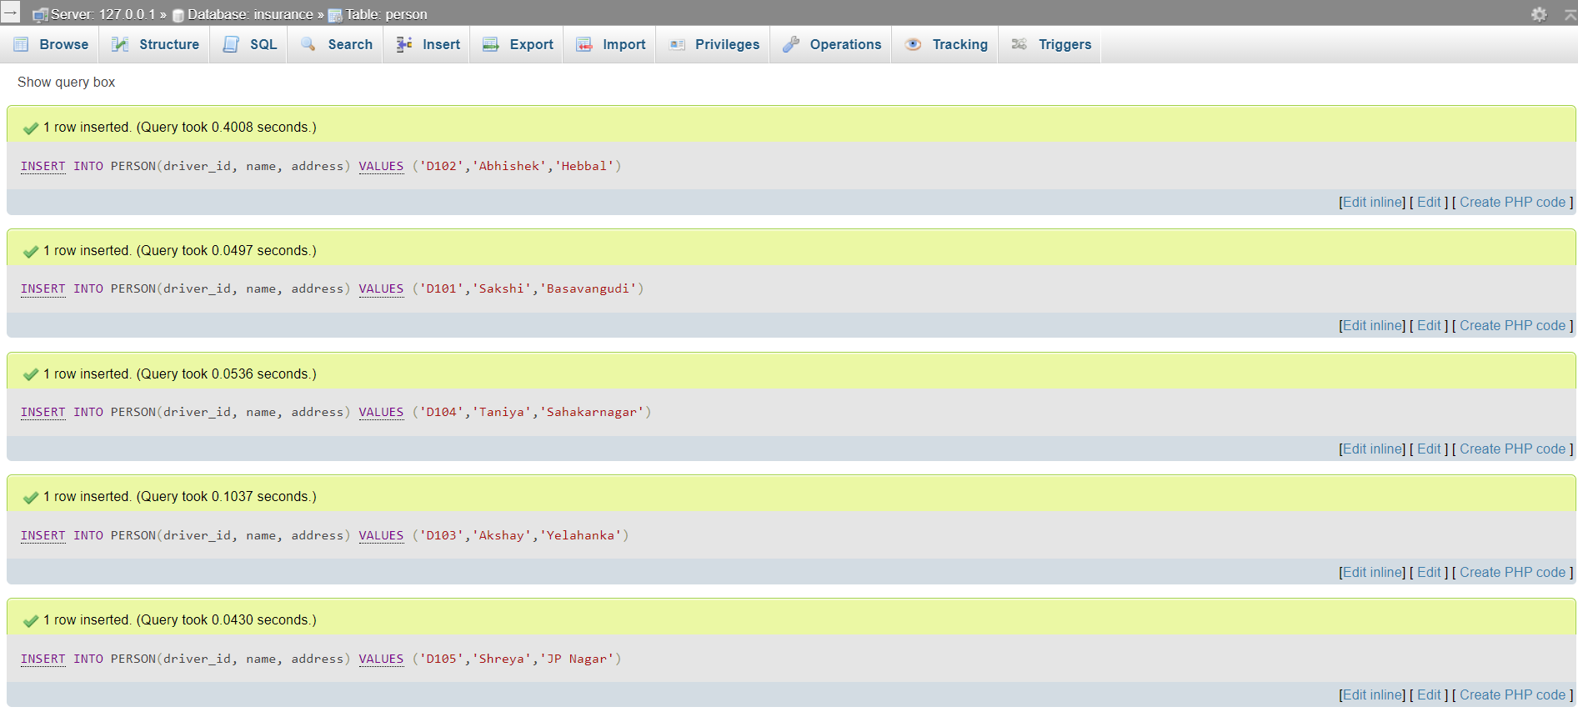

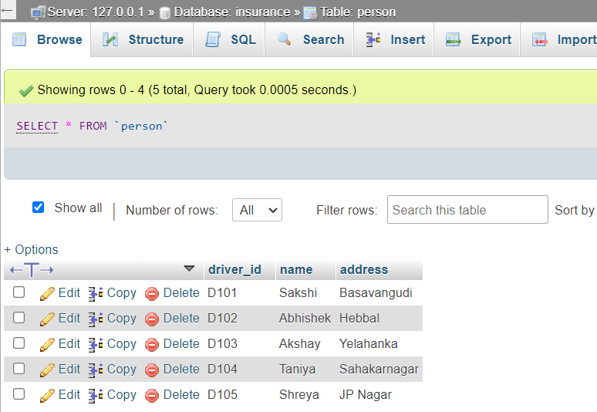

**‘CAR’ table:**

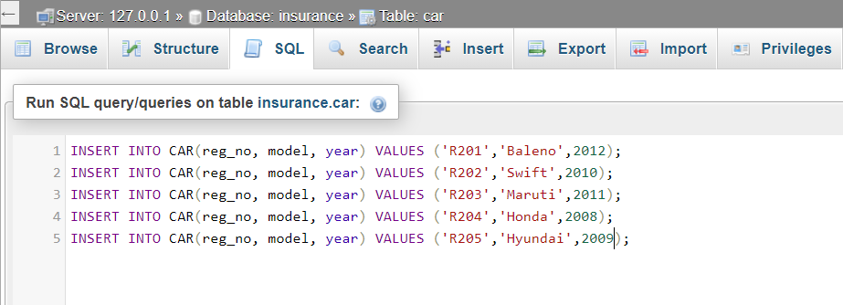

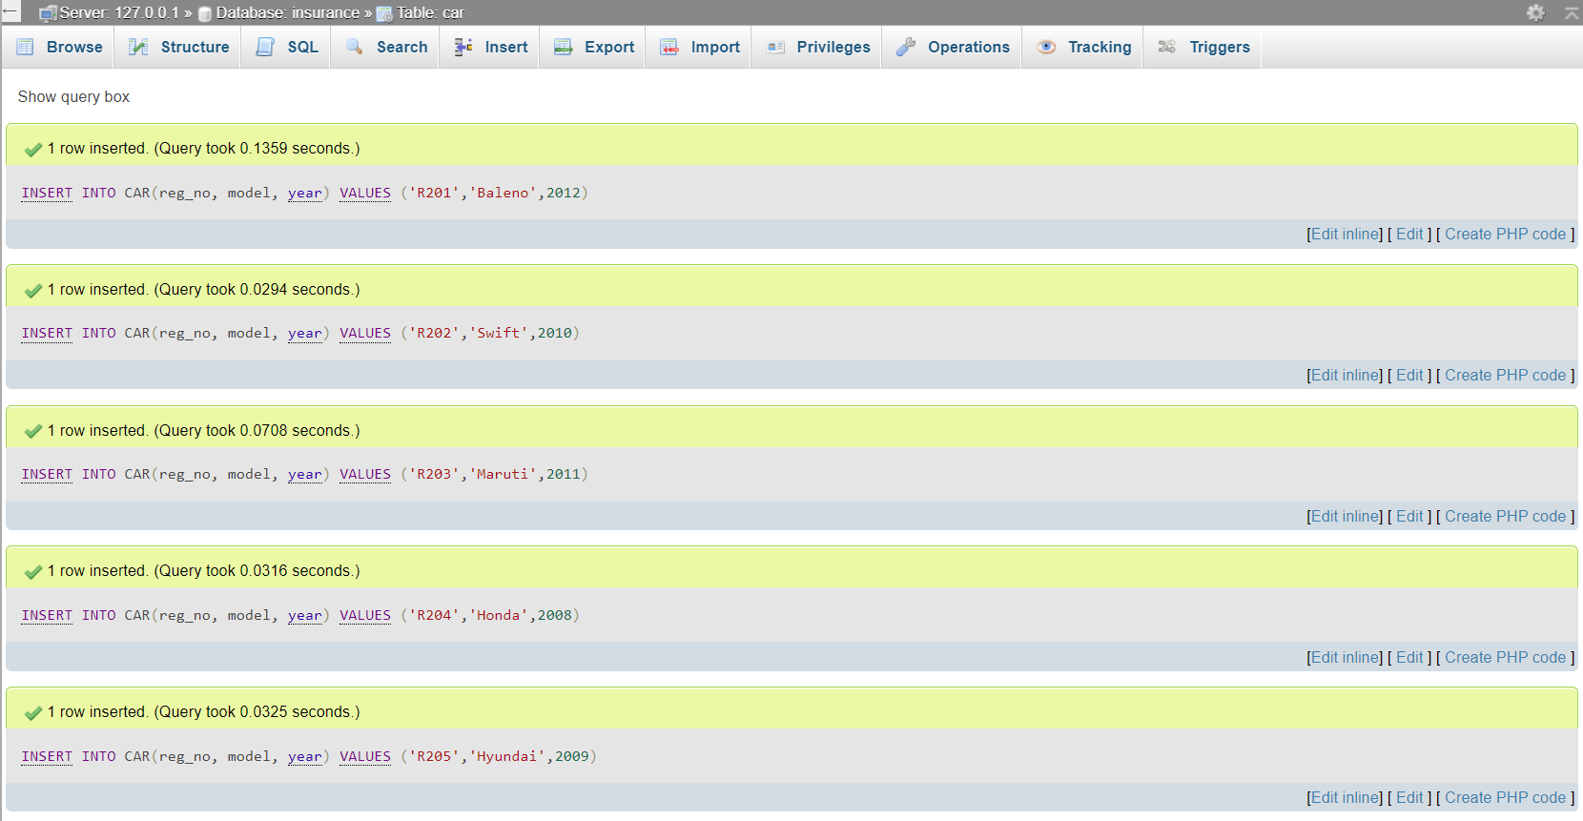

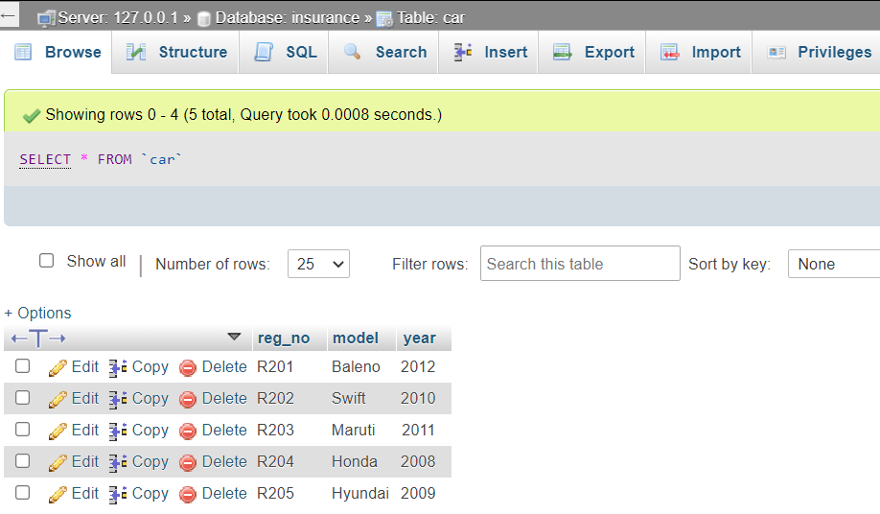

**‘ACCIDENT’ table:**

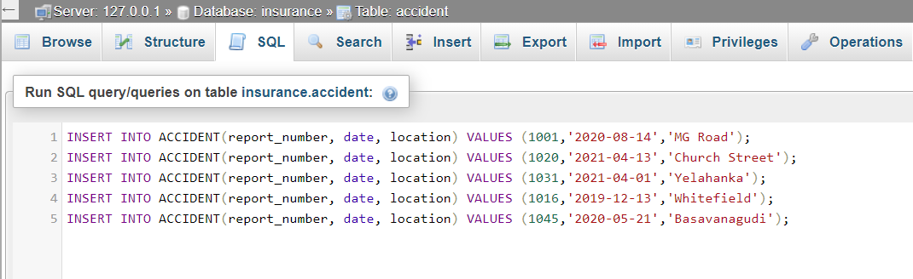

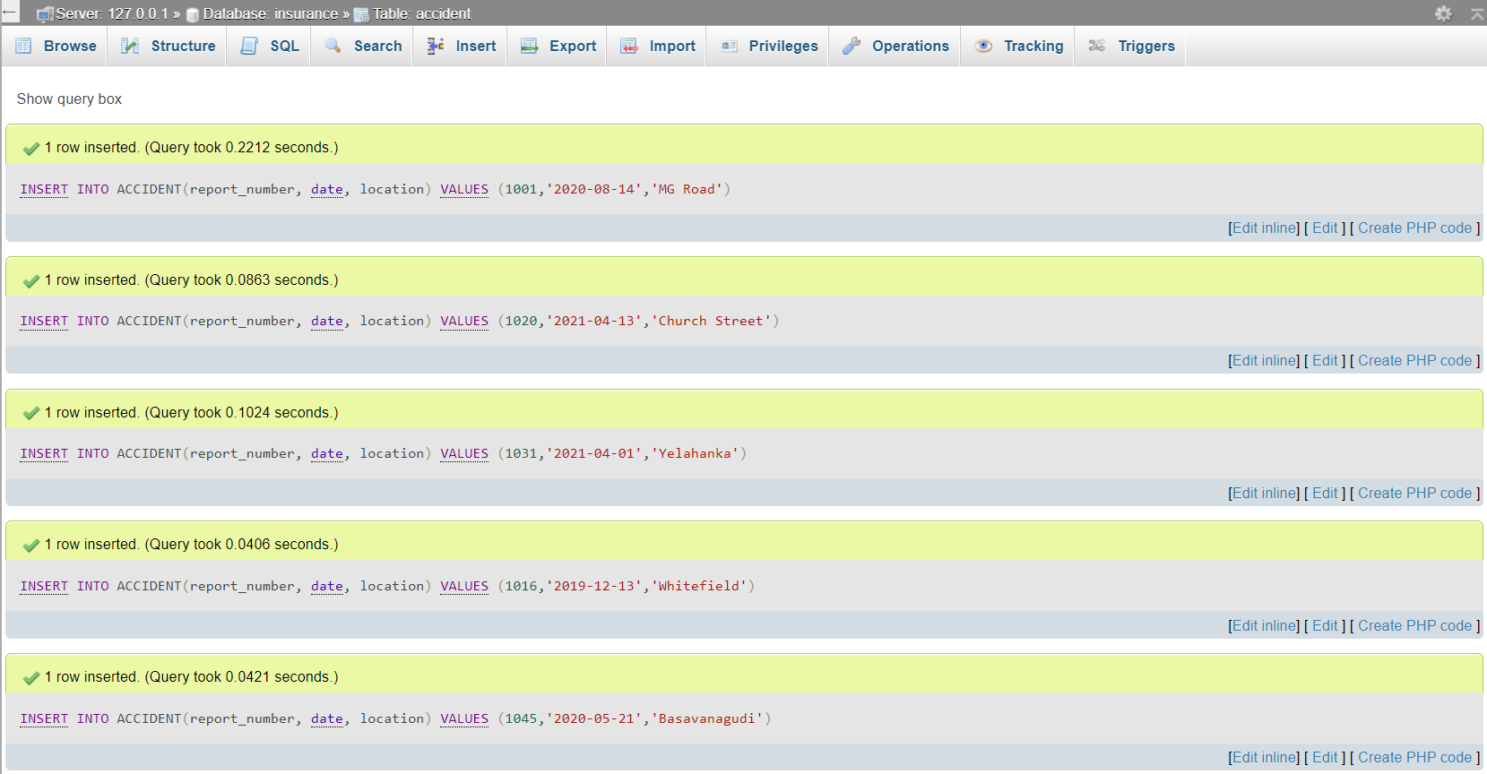

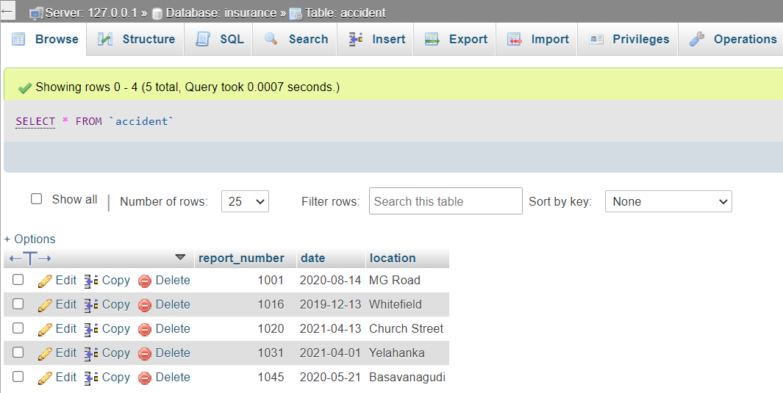

**‘OWNS’ table:**

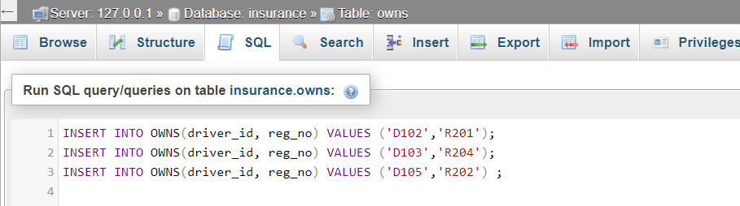

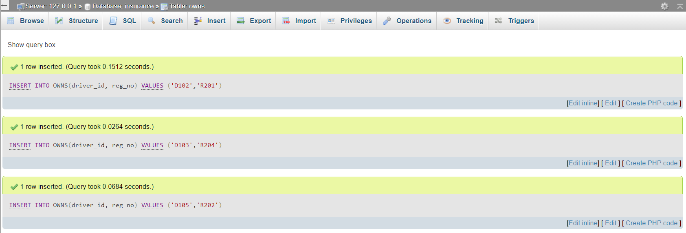

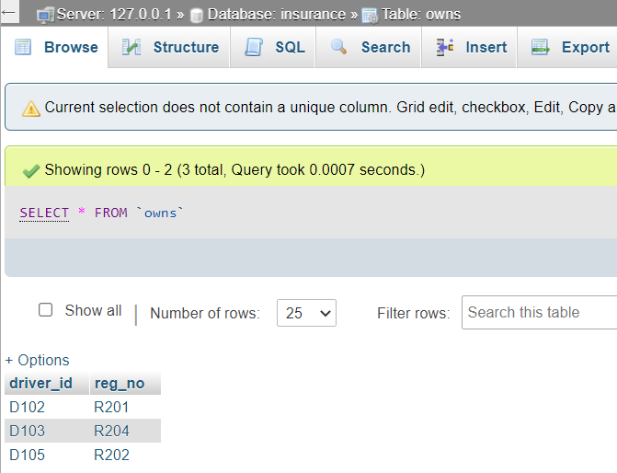

**‘PARTICIPATED’ table:**

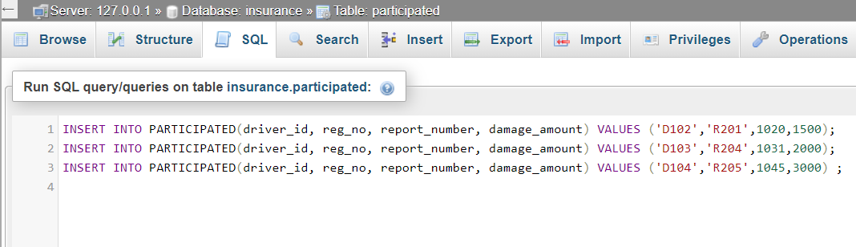

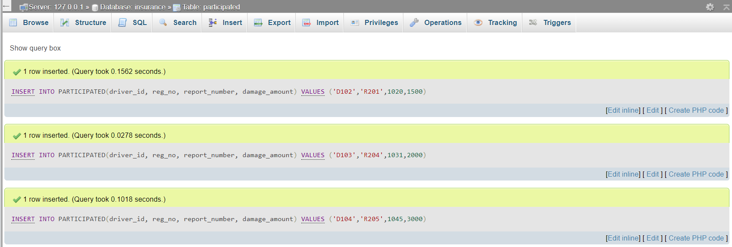

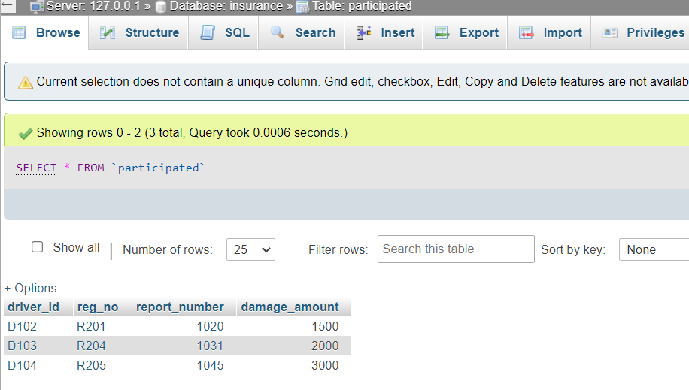

1. **Demonstrate how you**
2. **Update the damage amount for the car with a specific Regno in the accident with report number 12 to 25000.**

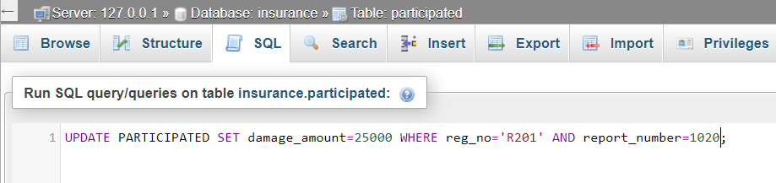

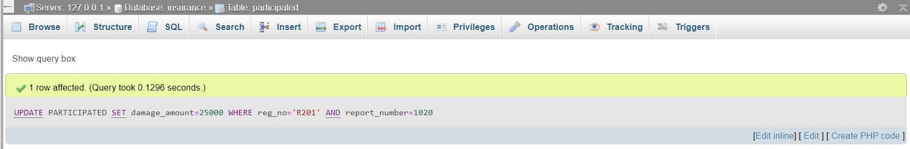

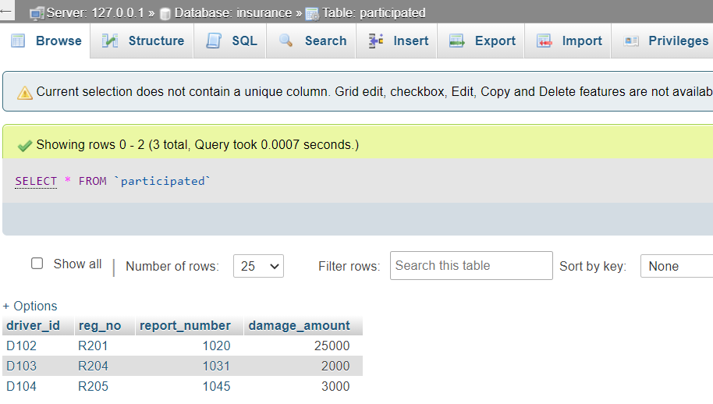

**b) Add a new accident to the database.**

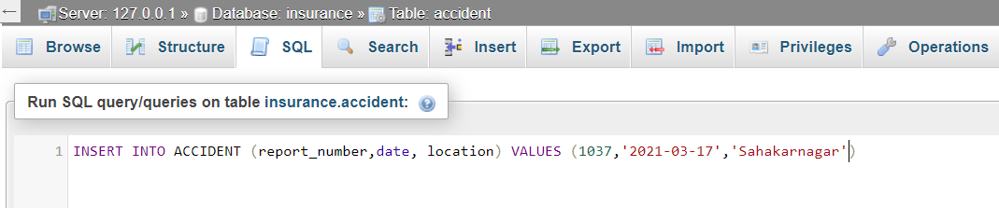

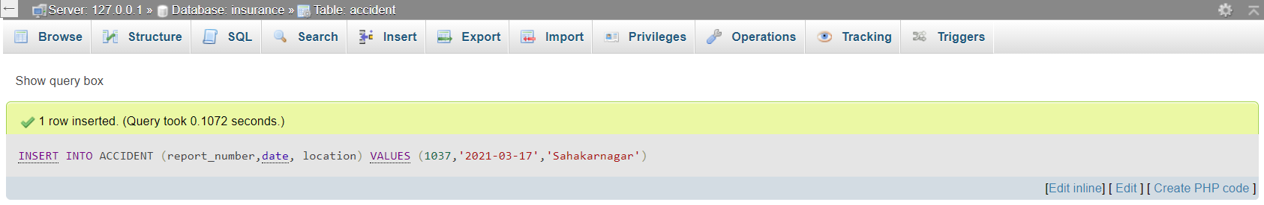

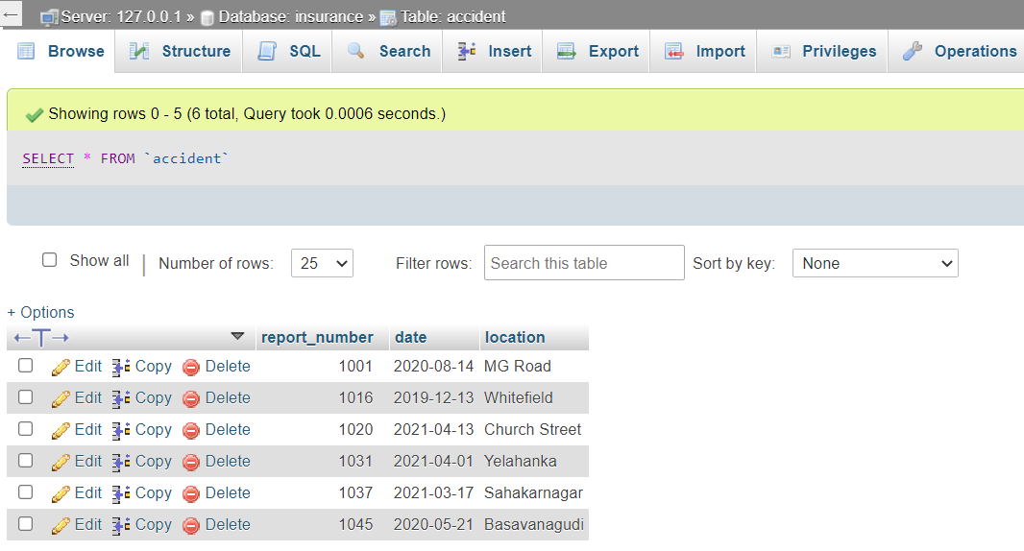

1. **Find the total number of people who owned cars that were involved in accidents in 2021.**

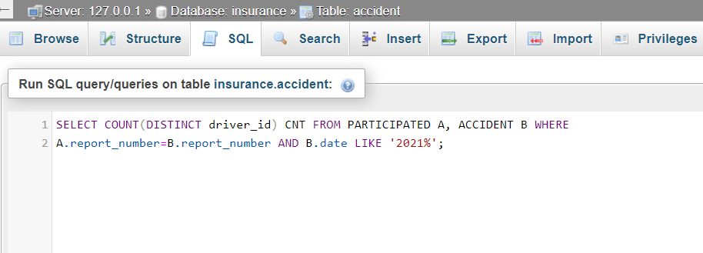

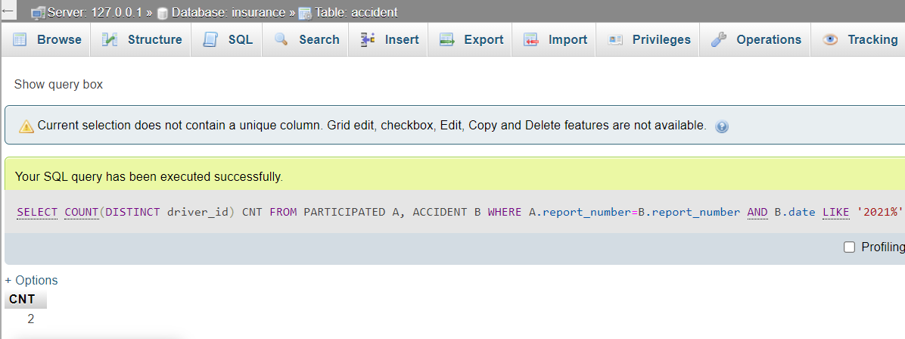

1. **Find the number of accidents in which cars belonging to a specific model (say ‘Hyundai’) were involved.**

